FARM MANAGEMENT SYSTEM
A Project Report
Submitted in partial fulfillment of the requirements for the award of the degree of
BACHELOR OF COMPUTER APPLICATIONS (BCA)
Submitted By
Kumaran M
Department of Computer Applications
E.S Arts and Science College (Co-Ed)
Academic Year 2026–2027
ABSTRACT
Farm Management System is a web-based application designed to help farmers and farm administrators organize day-to-day agricultural activities in a structured digital environment. Traditional farm records are often maintained in notebooks or spreadsheets, which makes it difficult to track crop details, labor, stock, expenses, sales, and profitability over a long period. The proposed system centralizes these activities and provides quick access to accurate records.
The system contains modules for user authentication, farm and field details, crop planning, worker management, inventory, supplier records, expense tracking, sales management, task scheduling, and summary reports. The application stores data in a MySQL database and can be implemented using HTML, CSS, and JavaScript for the user interface with PHP for server-side processing. Role-based access can be used so that authorized users can maintain records safely.
The main purpose of the project is to reduce paperwork, improve traceability, support better planning, and provide simple reports such as crop-wise cost, stock status, worker payments, sales revenue, and profit or loss. The system is designed for small and medium farms and can later be extended with weather integration, IoT sensors, mobile applications, and data analytics.
The proposed application follows a simple and practical workflow in which authorized users can create farm records, update crop activities, record purchases and expenses, maintain worker details, and enter sales information from a common interface. Input validation and structured database tables help reduce duplicate or incomplete records, while dashboard summaries make important information available for routine farm decisions. This approach improves consistency, reduces calculation errors, and makes historical farm data easier to review during planning and reporting.
Keywords: Farm Management, Agriculture, Crop Management, Inventory, Expenses, Sales, MySQL, Web Application.
TABLE OF CONTENTS
Section | Title
Chapter 1 | Introduction
Chapter 2 | System Study and Feasibility Analysis
Chapter 3 | Requirements Specification
Chapter 4 | System Design
Chapter 5 | Database Design
Chapter 6 | Module Description
Chapter 7 | Implementation
Chapter 8 | Testing and Validation
Chapter 9 | Results and Discussion
Chapter 10 | Security, Limitations and Future Enhancements
Chapter 11 | Conclusion
Appendix A | Sample Database Schema
Appendix B | Sample Test Data and Reports
Bibliography | References

CHAPTER 1
INTRODUCTION

1.1 Background
Agriculture involves many activities such as land preparation, crop selection, seed purchase, fertilizer use, irrigation, labor allocation, harvesting, storage, and sales. When these activities are recorded manually, data can be scattered across notebooks, bills, and individual spreadsheets. As the number of crops, workers, suppliers, and transactions increases, finding accurate information becomes difficult and time-consuming.
A Farm Management System provides a digital method for maintaining these records. It helps the farm owner or administrator enter information once and retrieve it whenever required. By organizing operational and financial information together, the system supports better control over resources and allows management to compare expected and actual outcomes.

1.2 Problem Statement
Many small and medium farms do not have a single application to maintain farm activities. This can lead to missing records, duplicate entries, difficulty in calculating total crop cost, uncertainty about available stock, delayed worker payments, and poor visibility of profit or loss. The proposed project addresses these problems through a centralized, user-friendly system.

1.3 Objectives
- To maintain farm, field, and crop information in a structured database.
- To track sowing, expected harvest, and crop status.
- To record workers, attendance or assigned tasks, wages, and payments.
- To manage seeds, fertilizers, pesticides, tools, and other inventory items.
- To record operational expenses and supplier transactions.
- To maintain harvest and sales details for each crop.
- To generate useful summaries for cost, revenue, stock, and profit or loss.
- To reduce manual paperwork and improve data accuracy and accessibility.

1.4 Scope of the Project
The project focuses on digital record management for a single farm or a small group of farms managed by one organization. It supports farm profile details, crop cycles, workers, inventory, purchases, expenses, sales, and reports. The first version does not require advanced hardware or sensors and can operate as a normal web application on a local server or deployed server.

1.5 Benefits
- Faster retrieval of farm records.
- Better control over stock and spending.
- Clear crop-wise financial summaries.
- Reduced calculation errors.
- Improved task planning and accountability.
- Easy preparation of reports for review.
CHAPTER 2
SYSTEM STUDY AND FEASIBILITY ANALYSIS

2.1 Existing System
In a traditional environment, farm information is recorded in notebooks, printed bills, mobile notes, or separate spreadsheet files. This method is simple initially but becomes difficult when the number of records grows. It also depends heavily on the person who maintains the records.
Existing Practice | Common Issue
Paper-based crop register | Records may be lost, damaged, or difficult to search.
Separate expense notes | Total cost for a crop is hard to calculate.
Manual stock checking | Shortage or over-purchase may occur.
Worker wage notebook | Payment history may be incomplete.
Sales bills only | Revenue is not automatically linked with crop cost.

2.2 Proposed System
The proposed Farm Management System stores all major farm records in a relational database. Authorized users can add, edit, search, and review information through web forms. The system connects crop activity with expenses, inventory usage, labor, harvest, and sales so that the user can obtain meaningful reports.

2.3 Feasibility Study

Technical Feasibility
The system can be developed using widely available web technologies and MySQL. It can run on ordinary desktop or laptop computers and does not require specialized hardware.

Economic Feasibility
The software can be built using open-source development tools. This keeps development and maintenance costs low for an academic project and for small-scale deployment.

Operational Feasibility
The user interface uses familiar forms, tables, search options, and dashboard summaries. Users with basic computer knowledge can operate the system after simple training.

Schedule Feasibility
The project can be divided into modules and developed incrementally within a typical academic semester.

Security Feasibility
Authentication, authorization, password hashing, input validation, database constraints, and backups can be included using standard development practices.

2.4 Comparative Summary
Feature | Manual System | Proposed System
Search | Slow | Fast database search
Data duplication | Common | Reduced using centralized records
Calculation | Manual | Automatic summaries
Reports | Prepared manually | Generated from stored data
Security | Physical access only | Login and role-based access
Backup | Difficult | Database backup possible

CHAPTER 3
REQUIREMENTS SPECIFICATION

3.1 Functional Requirements
- User Registration/Login: authenticate authorized users and maintain session control.
- Dashboard: display counts, pending tasks, low-stock items, current crops, recent expenses, and sales summary.
- Farm Management: maintain farm name, location, total area, soil notes, and field/plot details.
- Crop Management: record crop name, variety, sowing date, area, expected harvest date, status, and yield.
- Worker Management: maintain worker contact information, work assignments, attendance or work days, wage rate, and payment status.
- Inventory Management: maintain seed, fertilizer, pesticide, feed, tool, or equipment stock and minimum stock level.
- Supplier Management: maintain supplier profile and purchase details.
- Expense Management: record category, amount, date, payment mode, crop reference, and description.
- Sales Management: record harvest sale, buyer, quantity, unit price, total amount, and payment details.
- Reports: generate crop-wise, date-wise, expense, inventory, sales, and profit/loss summaries.

3.2 Non-Functional Requirements
- Usability: simple navigation and understandable field labels.
- Performance: common operations should respond quickly for normal academic-scale data.
- Reliability: database constraints and validation should reduce invalid records.
- Maintainability: modular code and normalized tables should simplify future changes.
- Security: protected passwords, validated inputs, restricted actions, and controlled sessions.
- Portability: application should run in a standard modern web browser.

3.3 Hardware Requirements
Component | Minimum / Suggested
Processor | Dual-core processor or above
RAM | 4 GB minimum; 8 GB suggested
Storage | 2 GB free space for project and database
Display | 1366 × 768 or above
Network | Optional for local use; required for online deployment

3.4 Software Requirements
Software | Purpose
Operating System | Windows 10/11 or Linux
Frontend | HTML5, CSS3, JavaScript
Backend | PHP 8.x or equivalent server-side technology
Database | MySQL 8.x
Web Server | Apache / XAMPP for local development
Editor | Visual Studio Code
Browser | Google Chrome / Microsoft Edge / Firefox

CHAPTER 4
SYSTEM DESIGN

4.1 System Architecture
The application follows a three-layer web architecture. The presentation layer receives user input through browser pages. The application layer validates requests, performs business logic, and communicates with the database. The data layer stores users, farms, crops, workers, inventory, expenses, purchases, and sales in MySQL.
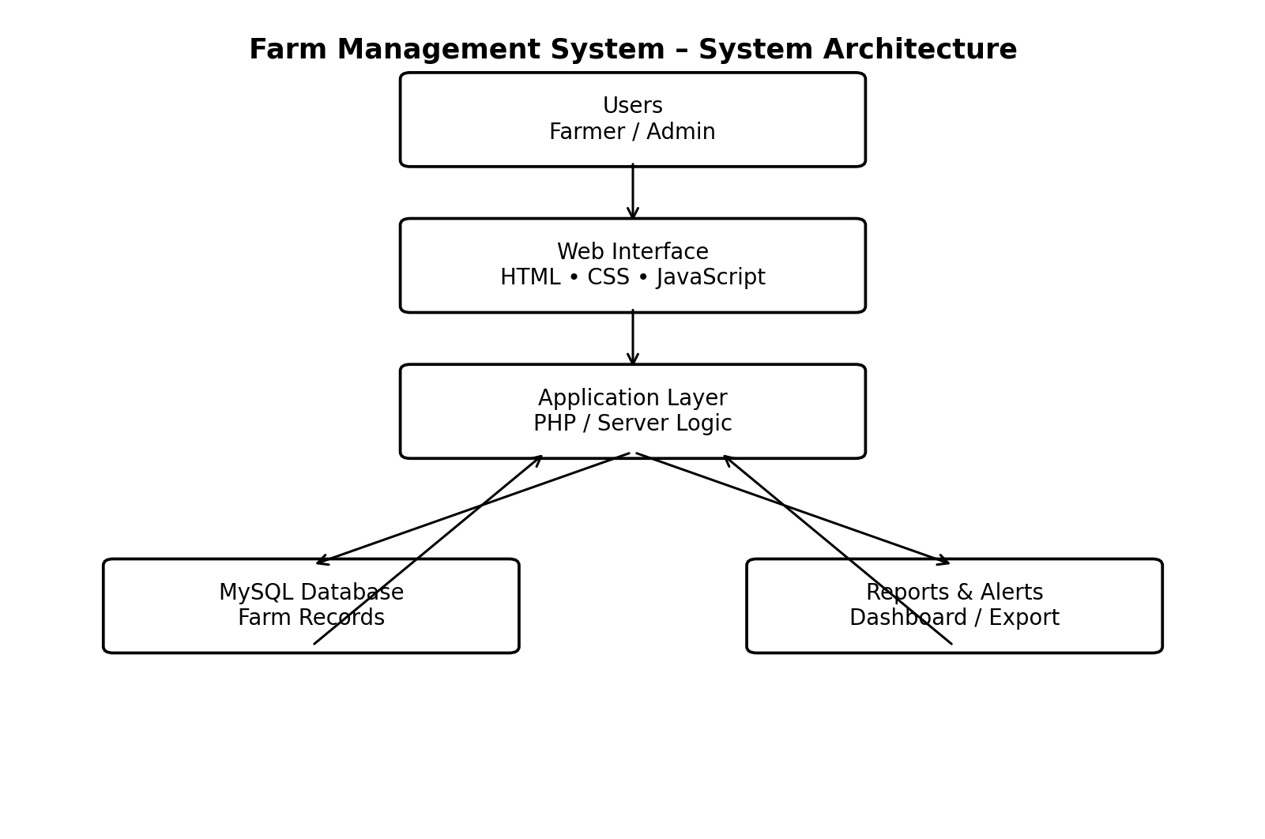
Figure 4.1 System Architecture

4.2 Data Flow Diagram
The Level-0 data flow diagram shows the main flow between the farmer or administrator, the Farm Management System, customer or buyer information, and the database stores. Detailed modules can be expanded into Level-1 processes such as crop management, inventory management, expense entry, and sales processing.
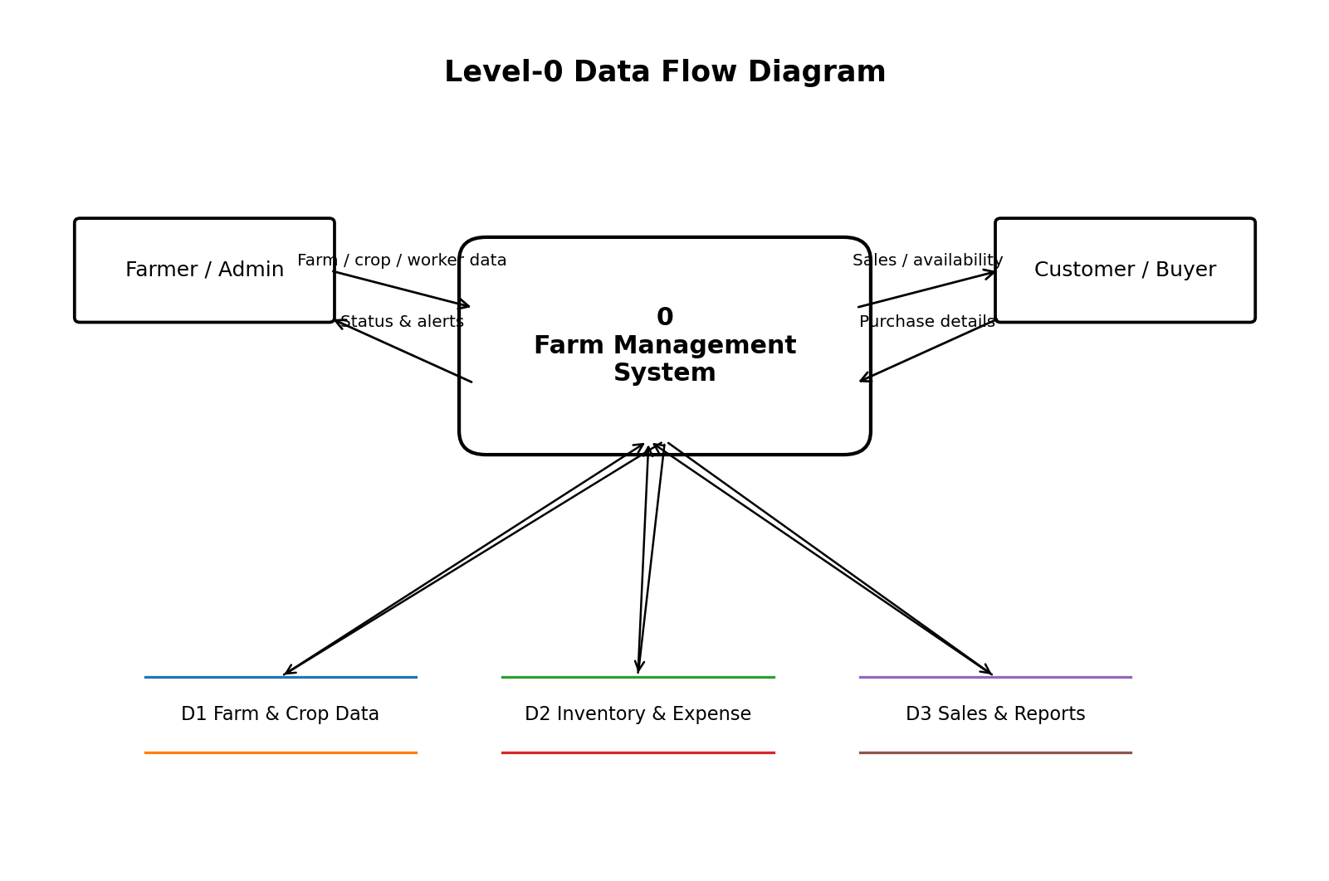
Figure 4.2 Level-0 Data Flow Diagram

4.3 Use Case Summary
Actor | Main Use Cases
Administrator | Login, manage users, farm details, crops, inventory, workers, expenses, sales, reports, backup.
Farm Staff | View assigned tasks, update approved operational records, enter daily activities where permission is given.
Buyer / Customer Record | Stored as a transaction entity for sales; does not require system login in the basic version.

4.4 Navigation Design
The suggested main navigation contains Dashboard, Farms/Fields, Crops, Workers, Inventory, Suppliers, Expenses, Sales, Reports, and Settings. Each module contains an Add form, list view, search/filter controls, and edit/delete actions according to user permissions.

4.5 Input Design
Input forms should use required-field validation, appropriate date controls, numeric validation for quantity and amount fields, and dropdown lists for categories. Destructive actions such as deletion should require confirmation. Error messages should be displayed near the related field whenever possible.

4.6 Output Design
Outputs include dashboard cards, tabular records, stock status, monthly expense summaries, crop cost reports, sales reports, and profit/loss statements. Reports should support date filters and printable layouts. Values should be formatted consistently with units and currency symbols configured for the user.
CHAPTER 5
DATABASE DESIGN

5.1 Entity Relationship Overview
The database is designed using related tables so that information can be stored without unnecessary duplication. Primary keys uniquely identify records and foreign keys connect related entities such as farm, crop, expense, and sale.
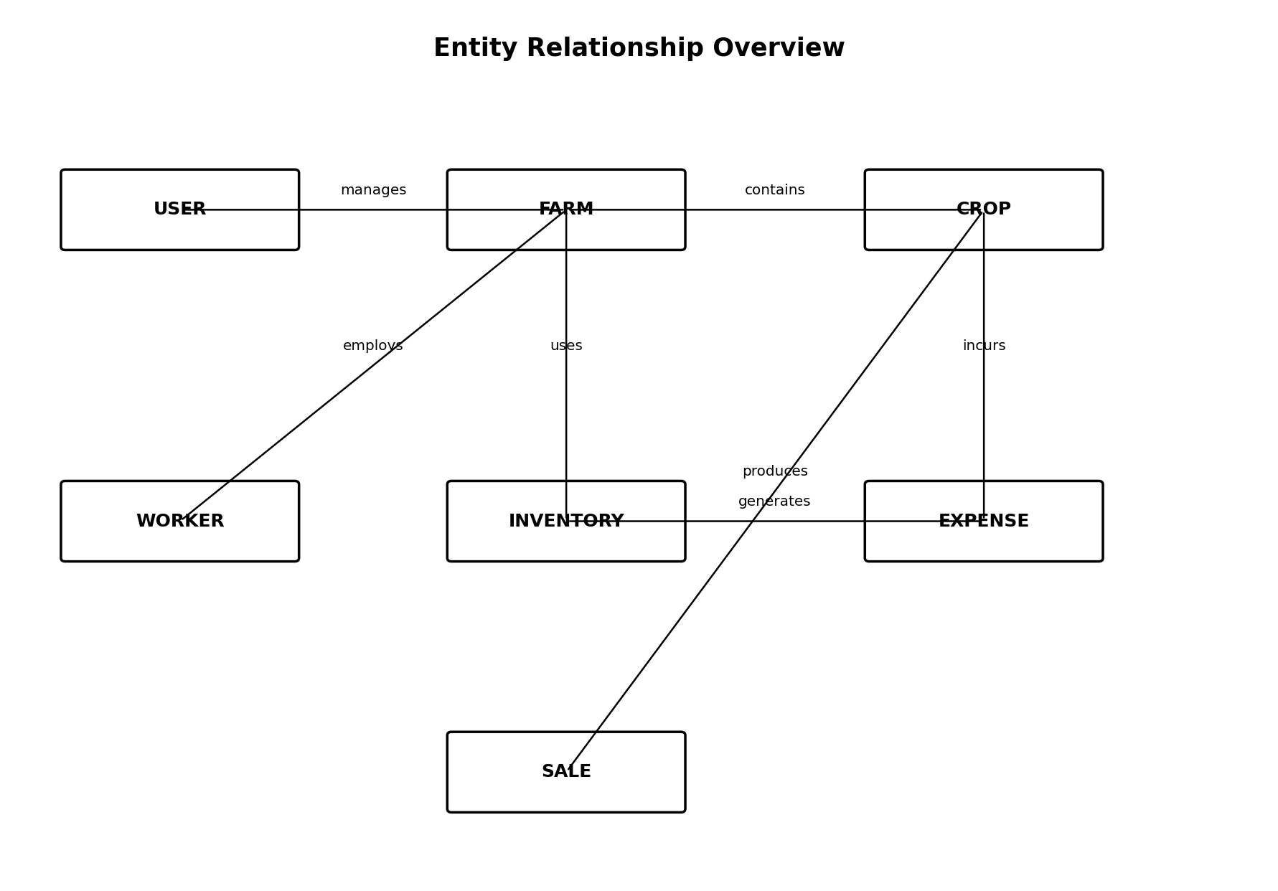
Figure 5.1 Entity Relationship Overview

5.2 Main Tables
Table | Purpose | Important Fields
users | Login and user profile | user_id, name, email, password_hash, role
farms | Farm master data | farm_id, user_id, farm_name, location, area
fields | Individual plots/fields | field_id, farm_id, field_name, area, soil_type
crops | Crop cycle details | crop_id, field_id, crop_name, sowing_date, harvest_date, status
workers | Worker master data | worker_id, farm_id, name, phone, wage_rate
tasks | Assigned farm tasks | task_id, crop_id, worker_id, task_date, status
inventory | Stock items | item_id, farm_id, item_name, category, qty, unit, reorder_level
suppliers | Supplier master data | supplier_id, name, phone, address
purchases | Stock purchase records | purchase_id, supplier_id, item_id, qty, total_amount, date
expenses | Farm/crop expenses | expense_id, crop_id, category, amount, date
sales | Harvest sales | sale_id, crop_id, buyer_name, qty, unit_price, total_amount, date

5.3 Normalization
The database design follows basic normalization principles. Repeating groups are separated into individual tables, master data is stored once, and transaction tables refer to master records using keys. This reduces duplicate information and improves consistency when values are updated.
CHAPTER 6
MODULE DESCRIPTION

6.1 Authentication and User Module
Controls login, logout, user profile, role, and session. Passwords should be stored as hashes and never as plain text.

6.2 Dashboard Module
Provides a quick view of current crops, total farm area, pending tasks, low-stock items, recent expenses, recent sales, and summary financial figures.

6.3 Farm and Field Module
Stores basic farm information and divides the farm into manageable plots or fields. Soil type, area, irrigation notes, and field status can be stored.

6.4 Crop Management Module
Maintains crop name, variety, plot, season, sowing date, expected harvest date, actual harvest date, area, planned yield, actual yield, and status.

6.5 Worker and Task Module
Stores worker details, wage rate, assigned tasks, work date, attendance or completion status, and payment notes.

6.6 Inventory Module
Tracks stock quantity for seeds, fertilizers, pesticides, tools, spare parts, or other farm inputs. A reorder level can identify low-stock items.

6.7 Supplier and Purchase Module
Maintains supplier data and records purchases that increase available stock and contribute to operational cost.

6.8 Expense Module
Records expenses such as seed, fertilizer, pesticide, labor, irrigation, electricity, transport, equipment repair, fuel, and miscellaneous costs.

6.9 Sales Module
Records crop sales with buyer, quantity, price, amount, date, and payment status. Sales can be linked to the related crop cycle.

6.10 Reports Module
Generates farm summary, crop cost, worker payment, stock, purchase, expense, sales, and profit/loss reports with date and crop filters.
CHAPTER 7
IMPLEMENTATION

7.1 Development Environment
The suggested implementation uses Visual Studio Code as the editor, XAMPP as the local Apache/PHP environment, and MySQL for the database. The frontend is created using HTML, CSS, and JavaScript. PHP receives form submissions, validates inputs, executes parameterized database queries, and returns the requested pages or JSON responses.

7.2 Folder Structure
Path | Description
/config | Database connection and application configuration
/auth | Login, logout, access-control logic
/modules/farms | Farm and field operations
/modules/crops | Crop operations
/modules/workers | Worker and task operations
/modules/inventory | Inventory and purchase operations
/modules/finance | Expense and sales operations
/reports | Report generation pages
/assets/css | Stylesheets
/assets/js | Client-side scripts
/database | SQL schema and sample data

7.3 Core Processing Logic
- Validate user login before displaying protected pages.
- Validate and sanitize all form values before saving.
- Use prepared statements for database operations.
- Store transaction records with timestamps.
- Update inventory quantity when purchases or approved usage are recorded.
- Calculate sale total from quantity and unit price.
- Calculate crop profit/loss as total crop sales minus total linked expenses.

7.4 Sample Calculations
Calculation | Formula
Sale Total | Quantity Sold × Unit Price
Crop Total Expense | Sum of all expenses linked to the crop
Crop Revenue | Sum of all sales linked to the crop
Profit / Loss | Crop Revenue − Crop Total Expense
Inventory Balance | Opening/Existing Stock + Purchases − Usage/Issue

7.5 Validation Rules
- Dates must be valid and relevant to the crop cycle.
- Area, quantity, wage, price, and amount must be non-negative numeric values.
- Email fields should follow a valid email pattern where applicable.
- Phone numbers should accept only the configured valid format.
- Foreign-key selections must refer to existing active records.
- Delete operations should be restricted when dependent transactions exist or handled using controlled archival.
CHAPTER 8
TESTING AND VALIDATION

8.1 Testing Strategy
Testing is performed at the module level and at the integrated system level. Each form is checked using valid, invalid, boundary, and duplicate data. Database operations are verified to ensure that the correct rows are inserted, updated, retrieved, or rejected. Access-control checks are performed for pages that require authentication.

8.2 Sample Test Cases
TC ID | Test Scenario | Input / Action | Expected Result
TC01 | Valid login | Correct username and password | Dashboard opens successfully.
TC02 | Invalid login | Wrong password | Error message; access denied.
TC03 | Add crop | All required crop fields | Crop record saved.
TC04 | Missing crop name | Crop name blank | Validation message shown.
TC05 | Add inventory item | Valid quantity and unit | Item saved with stock balance.
TC06 | Negative quantity | Quantity = -5 | Record rejected.
TC07 | Add expense | Valid crop, category, amount | Expense saved and reflected in report.
TC08 | Add sale | Quantity and unit price entered | Total calculated and saved.
TC09 | Low stock report | Balance below reorder level | Item appears in low-stock list.
TC10 | Unauthorized page | Open protected URL after logout | Redirect to login.

8.3 Validation Result
The proposed test set confirms that normal user operations, input validation, transaction calculations, and access control can be verified systematically. Additional tests should be added for deployment-specific features such as email notifications, API integrations, and bulk data import if those features are implemented.
CHAPTER 9
RESULTS AND DISCUSSION

9.1 Expected Dashboard Output
After login, the dashboard presents essential farm information in a summarized form. Suggested cards include Active Crops, Total Fields, Pending Tasks, Low Stock Items, Monthly Expense, Monthly Sales, and Estimated Profit/Loss. Recent activities may be shown below the summary.
Dashboard Card | Example Value | Meaning
Active Crops | 4 | Four crop cycles are currently active.
Pending Tasks | 7 | Seven planned tasks are not yet completed.
Low Stock Items | 3 | Three inventory items are below reorder level.
Monthly Expense | ₹48,500 | Total farm expenses entered for the current month.
Monthly Sales | ₹72,000 | Total sales entered for the current month.

9.2 Example Crop Summary
Field | Sample Data
Crop | Paddy – ADT 43
Field | North Field
Area | 2.0 acres
Sowing Date | 15-07-2026
Expected Harvest | 10-11-2026
Total Expense | ₹62,300
Sales Revenue | ₹84,000
Profit / Loss | ₹21,700 Profit

9.3 Discussion
The system improves visibility by connecting operational and financial records. A user can review the cost of a crop, identify large expense categories, check available inputs, and compare sales with total cost. This is more useful than isolated records because the information is organized around farm activities and crop cycles.
The quality of the reports depends on the accuracy and timeliness of data entry. Therefore, the system should encourage regular updates and clearly distinguish planned values from actual values. Backup and access-control procedures are also important for practical use.
CHAPTER 10
SECURITY, LIMITATIONS AND FUTURE ENHANCEMENTS

10.1 Security Considerations
- Store passwords using a secure password-hashing algorithm.
- Use prepared SQL statements to reduce SQL injection risk.
- Validate and sanitize all server-side input.
- Use session timeouts and logout controls.
- Restrict administrative functions by role.
- Maintain regular database backups.
- Use HTTPS when the application is deployed online.
- Log important changes such as record deletion or financial edits where appropriate.

10.2 Current Limitations
- The basic version depends on manual data entry.
- Weather and market-price data are not automatically fetched.
- No real-time IoT sensor integration is included in the initial version.
- Financial reports are operational summaries and not a substitute for formal accounting software.
- Mobile experience depends on responsive web design unless a separate app is created.

10.3 Future Enhancements
- Weather API integration with rain and temperature alerts.
- Market-price integration for selected crops.
- Mobile application for field data entry.
- GPS-based field mapping.
- IoT integration for soil moisture, tank level, and environmental sensors.
- Image-based crop disease assistance with appropriate accuracy disclaimers.
- Predictive analytics for yield and expense trends.
- Automated reminders for irrigation, fertilizer schedule, tasks, and harvest.
- Multi-language interface, including Tamil and English.
- Cloud backup and multi-farm collaboration.
CHAPTER 11
CONCLUSION
The Farm Management System provides a practical digital solution for organizing agricultural records and routine farm operations. By combining farm details, crop cycles, labor, inventory, expenses, purchases, sales, and reports in one system, it reduces dependence on scattered manual records and helps users understand the current status of farm activities.
The project is suitable for a BCA-level implementation because it applies core concepts of web development, database management, authentication, CRUD operations, validation, reporting, and software testing. The modular design also allows additional features to be added without rebuilding the entire application.
With careful data entry, access control, regular backup, and future integration with weather, sensors, or analytics, the system can evolve from an academic project into a useful decision-support application for real farm operations.
APPENDIX A
SAMPLE DATABASE SCHEMA

Table: users
CREATE TABLE users (
user_id INT AUTO_INCREMENT PRIMARY KEY,
full_name VARCHAR(100) NOT NULL,
email VARCHAR(120) UNIQUE NOT NULL,
password_hash VARCHAR(255) NOT NULL,
role VARCHAR(20) DEFAULT 'admin',
created_at TIMESTAMP DEFAULT CURRENT_TIMESTAMP
);

Table: farms
CREATE TABLE farms (
farm_id INT AUTO_INCREMENT PRIMARY KEY,
user_id INT NOT NULL,
farm_name VARCHAR(120) NOT NULL,
location VARCHAR(200),
total_area DECIMAL(10,2),
area_unit VARCHAR(20) DEFAULT 'acre',
FOREIGN KEY (user_id) REFERENCES users(user_id)
);

Table: crops
CREATE TABLE crops (
crop_id INT AUTO_INCREMENT PRIMARY KEY,
farm_id INT NOT NULL,
crop_name VARCHAR(100) NOT NULL,
variety VARCHAR(100),
sowing_date DATE,
expected_harvest_date DATE,
status VARCHAR(30) DEFAULT 'Planned',
FOREIGN KEY (farm_id) REFERENCES farms(farm_id)
);

Table: expenses
CREATE TABLE expenses (
expense_id INT AUTO_INCREMENT PRIMARY KEY,
crop_id INT,
category VARCHAR(80) NOT NULL,
amount DECIMAL(12,2) NOT NULL,
expense_date DATE NOT NULL,
description VARCHAR(255),
FOREIGN KEY (crop_id) REFERENCES crops(crop_id)
);

Table: sales
CREATE TABLE sales (
sale_id INT AUTO_INCREMENT PRIMARY KEY,
crop_id INT NOT NULL,
buyer_name VARCHAR(120),
quantity DECIMAL(12,2) NOT NULL,
unit VARCHAR(30),
unit_price DECIMAL(12,2) NOT NULL,
total_amount DECIMAL(12,2) NOT NULL,
sale_date DATE NOT NULL,
FOREIGN KEY (crop_id) REFERENCES crops(crop_id)
);
APPENDIX B
SAMPLE TEST DATA AND REPORTS

B.1 Sample Inventory Data
Item | Category | Quantity | Unit | Reorder Level | Status
Paddy Seed | Seed | 85 | kg | 30 | Available
Urea | Fertilizer | 18 | bags | 20 | Low Stock
DAP | Fertilizer | 25 | bags | 15 | Available
Neem Oil | Pesticide | 12 | litres | 10 | Available
Drip Connector | Spare | 8 | pieces | 10 | Low Stock

B.2 Sample Expense Report
Date | Crop | Category | Amount
16-07-2026 | Paddy | Seed | ₹8,500
19-07-2026 | Paddy | Labor | ₹12,000
28-07-2026 | Paddy | Fertilizer | ₹9,800
12-08-2026 | Paddy | Irrigation | ₹6,000
03-09-2026 | Paddy | Pesticide | ₹4,500

B.3 Sample Profit/Loss Report
Crop | Total Expense | Revenue | Profit/Loss
Paddy | ₹62,300 | ₹84,000 | ₹21,700 Profit
Groundnut | ₹44,500 | ₹58,200 | ₹13,700 Profit
Vegetables | ₹31,700 | ₹29,600 | ₹2,100 Loss

Note: The sample values in this appendix are illustrative test data prepared for demonstrating report formats. They are not real financial records.
BIBLIOGRAPHY
1. Roger S. Pressman and Bruce R. Maxim, Software Engineering: A Practitioner’s Approach, McGraw-Hill.
2. Ian Sommerville, Software Engineering, Pearson.
3. MySQL Reference Manual, Oracle Corporation.
4. MDN Web Docs, HTML, CSS, and JavaScript reference materials.
5. PHP Documentation, PHP Group.
6. Apache HTTP Server Documentation, Apache Software Foundation.

